

Proposal for

Artificial Intelligence Training and Digital Capability Development

Continuous Learning Platform



8th April 2026

- INTRODUCTION
  - Fidelity is undertaking a strategic initiative to preparing the organisation for the of Artificial Intelligence and other advanced digital technologies within its operations.

- PURPOSE

The design and delivery of structured AI training programmes, the development of customised training materials, the provision of a digital learning platform, and the establishment of a continuous learning environment

- OBJECTIVES
  - Increase Revenue – Training on AI Tools, Solutions and Skills that
    - Improve productivity by 100% in selected business functions
    - Improve selected top 5 revenue and customer growth drivers by at least 10%
  - Reduce Costs – Training on AI Tools, Solutions and Skills that
    - Improve selected top 5 cost drivers by at least 20%
    - Reduce compliance, risk and audit costs
  - Improve Efficiencies
    - Improve selected top 5 efficiencies across top 20 processes 20%
    - Improve performances for workflows, processes and ecosystems integration
  - AI and Digital Maturity Index – Improve AI and Digital Maturity Index by 30%
  - AI-powered Business Models – Prepare a future-proof Fidelity Group which can deploy future-proof AI-powered Digital Business Models

- SCOPE OF WORK
  - Fidelity Group AI Training - All Business Units and Departments
    - Accredited AI Business, Processes, Services and Technology Training
    - Technical Certification
  - Fidelity Academy and FinTech Business Unit
    - Partnership and Support in setting Up Launching Fidelity Academy
    - Deliver a implementation roadmap for a Fidelity FinTech Unit
  - IA-powered Learning Platform - Deliver an AI Training Platform for staff continuous learning
  - AI Readiness and Strategy - Deliver an AI Readiness, Implementation strategy and roadmap

- Training Methodology
  - Overall Methodology – the overall methodology we will follow is shown in the 6 steps below.
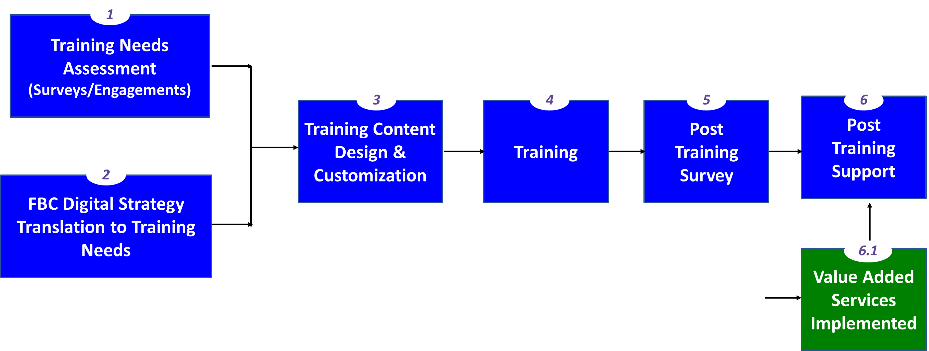
  - Training Module Sequence – the training is structured in hierarchy so starting with the foundation at the bottom and the modules that are dependent on others are sequentially done later on.
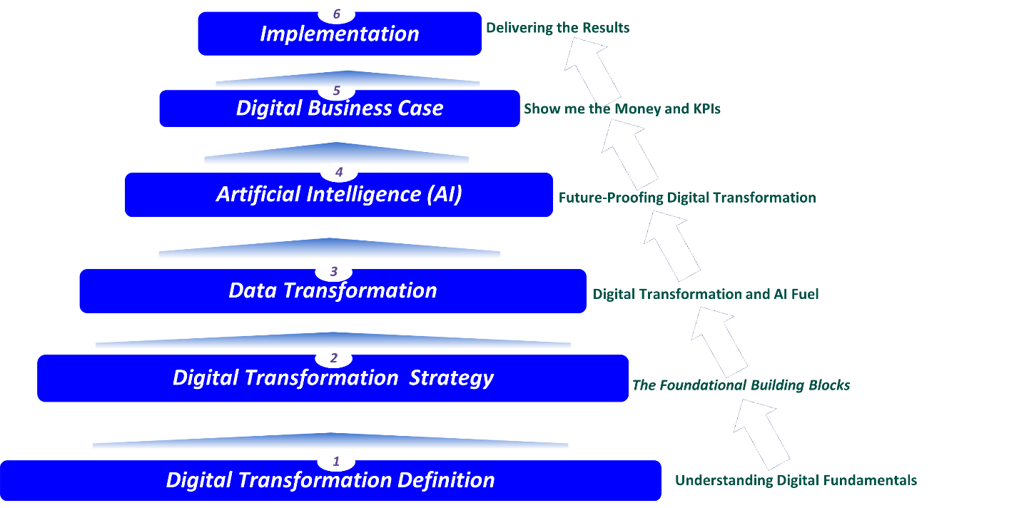

    - The training starts with providing an understanding of the digital transformation, explaining the basic theory, the practice in business and the trends.
    - The second level provides the framework, tools and practical approaches to design a digital transformation strategy. The material is customised to suit the different participants
    - The third level focuses on data transformation which is a requisite for any digital transformation to be successful. The content explains the strategies and technologies to create a data driven organisation
    - The fourth level introduces the basics of artificial intelligence (AI), how to design the strategy and the technologies that can be used. AI builds on top of digital transformation and Data. It future-proofs digital transformation and takes the organisation to new frontiers
    - The fifth layers deals with how to translate the digital transformation strategy into a business case, key performance indicators and critical success factors. It explains how a financial model to measure the value map can be developed
    - The final layer focuses on how to implement digital transformation to achieve the Liberty Group strategic objectives.

- TRAINING PROGRAM DESIGN
  - Design differentiated training programmes tailored to the various levels of responsibility and operational roles within the Fidelity Group.
    - The training is structured to accommodate the organisational structure and staff operational schedules.
    - The training materials shall be aligned with Fidelity’s operational procedures, policies, manuals, business processes, compliance, governance and strategic priorities
    - Training aligned with existing Fidelity training programmes and training facilities
    - The training shall integrate and build upon existing products, services, and technology systems, ensuring that AI and digital transformation addresses operational realities.
    - Training to include structured learning modules, assessment mechanisms, and formal certification processes designed to build AI expertise within Fidelity.

  - Fidelity Operational Readiness Assessment
    - Prior to the full rollout of the training programme, the successful bidder shall conduct a Fidelity Training Readiness Assessment.
    - The assessment ensures that the training programme is fully aligned with the operations, supports digital transformation and process automation initiatives.
    - The Assessment will enable development of AI and Digitalisation strategy and roadmap

  - AI Use Case Development Workshops for Fidelity Departments
    - The training programme shall include AI Use Case and AI Solutions Workshops for Fidelity Departments.
    - The purpose of these workshops shall be to move beyond theoretical awareness and training, and to delivery of practical skills, solutions and initiatives that deliver value
    - The outputs from the workshops shall be incorporated into the overall programme to support future AI strategy, solution design, and digital transformation planning.

- TRAINING DELIVERY MODEL
  - The training programme shall adopt a blended learning model designed to maximise participation and learning outcomes.
  - The delivery model shall include:
    - Classroom-based training sessions and interactive workshops
    - Online training sessions
    - Self-paced learning modules
  - Training will be multi-modal in real time, incorporating multiple methods of delivering learning content. It will incorporate the following delivery formats:
    - Text-based learning content
    - Video-based learning content
    - Audio-based learning content
  - Training will be multilingual to support accessibility across staff members. The languages supported shall include:
    - English
    - Shona
    - Ndebele
  - The programme shall be spread over 3 days (for Board), Couple of Days (for Management and Operations Staff) and 3 months for Technical Certification

- DELIVERABLES
  - Executive Leadership AI Training - The training is for Board and executive leadership responsible for strategic decision-making. A summary of the course is attached.
  - Management AI Training - The training is designed for managers, professionals responsible for implementing operational strategies. The training course is attached.
  - Operations Staff AI Training - The training focuses on staff responsible for operational processes and technical support functions. The training course is attached.
  - AI Technical Certification - The AI Technical Certification is designed for selected Fidelity staff who require deeper technical competence in AI and related technologies.
  - HEXCO and UZ Certificates - All delegates will receive HEXCO Accredited and UZ Certificates upon training completion

- DIGITAL TRAINING PLATFORM
  - Provide a digital training platform capable of supporting structured learning, continuous learning, and monitoring of training progress.
  - The platform must provide the following functionality:
    - Hosting of training content
    - Self-paced learning modules
    - Online examinations and self-testing functionality
    - Supervisor monitoring of staff training progress, reports and analysis
  - The platform shall allow real-time learning delivery and interactive sessions.
  - A detailed description and a Demo will be provided

- INTELLECTUAL PROPERTY AND PLATFORM OWNERSHIP
  - All customised training materials, documentation, digital learning resources, course content, training manuals, instructional media, and other materials developed specifically for Fidelity under this programme shall remain in use at Fidelity under license.
  - Fidelity shall have the option, upon completion of the programme, to acquire and continue using the AI Training platform.

- Company Profile
  - AI Institute Africa (AIIA)
    - The AIIA Profile is Attached. AIIA is the largest AI Institute in Africa
    - AIIA is HEXCO Accredited
    - AIIA has a partnership with UZ for quality assurance, Trainers and certificates offering
    - AIIA has highly qualified Trainers with practical Financial Services industry experience
    - Reference www.aiinstituteafrica.com

  - Rubiem Intelligence (Pvt) Ltd
    - Rubiem Innovations profile is attached. Rubiem Intelligence (Pvt) Ltd is sister company to rubiem Innovations
    - Rubiem is a Pan-African organisation offering Digital and Organisation Transformation services to blue-chip organisations
    - Rubiem References are attached below

  - IA Training References

The table below shows the Aiia References

- Trainers

The following AI and Digitalisation Trainers will be deployed to the Fidelity Training program

- Financial Proposal

The Training project price is shown below

Payment Terms

1.The payment terms 30% Deposit

2. Balance is spread per completed trained session - outcome based

- PROJECT PLAN
  - The high level project plan is shown below
  - The actual dates will be discussed and agreed with Fidelity Management

